**Expression of Interest**

**Straight Connector 10, Shape**

|  |  |
| --- | --- |
| **Expression of Interest (EOI)** | Wagga Airport Café – For Lease |
|  |  |
| **Deadline** | **Friday XX MONTH 2025 at 5.00pm** |
|  |  |
| **Address for Delivery** | Submissions must be lodged as follows:  **Electronic Submissions**:  Email to [engedal.borge@wagga.nsw.gov.au](mailto:engedal.borge@wagga.nsw.gov.au)  **Hard Copy Submissions:**  Deliver by hand to Customer Service at the Civic Centre, 243 Baylis St, Wagga Wagga NSW 2650, addressed to the Council Tender Box. |

Opportunity Overview

The City of Wagga Wagga is seeking expressions of interest (EOI) from experienced hospitality operators to lease and operate the Airport Café. The Airport Café is located within the airport terminal building at Wagga Wagga Airport, Don Kendell Dr, Forest Hill NSW 2650.   
    
The Wagga Wagga Airport is one of the busiest regional airports in New South Wales, with over 40 flights between Wagga Wagga and major cities each week, carrying more than 210,000 passengers annually. (I have confirmed numbers with Leon)

The Airport is a growing hub for commerce, employment, education and training in the aviation industry.

This is a rare and exciting opportunity to unlock the region's growing economic and tourism potential.

We welcome EOIs from experienced hospitality operators who are interested in managing and operating our café. Submissions must include a business plan for proposed activities, a detailed overview of industry experience, and details demonstrating financial capacity and readiness to fulfill lease requirements.

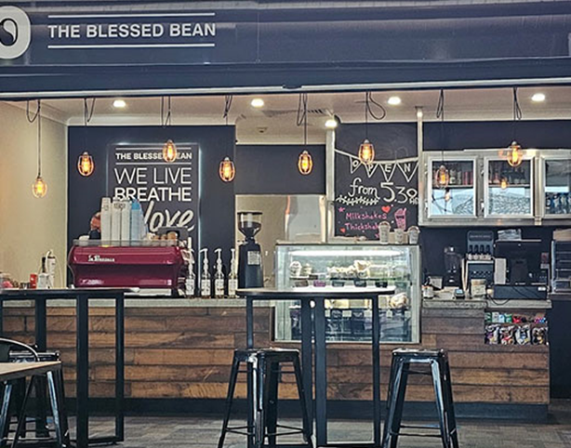

(Replace with new photos)

About the Space

|  |  |
| --- | --- |
| Size and layout | The café offers approximately 27m2 of lease space, with an additional licensed seating area available for café patrons to enjoy. |
| Location and accessibility | Situated within the airport terminal, the café benefits from a continuous flow of visitors and excellent exposure to high foot traffic. Both the terminal and café are thoughtfully designed to ensure full accessibility for all. |
| Amenities | The café features generous storage space and includes a dedicated restroom? The Lessee is to supply commercial appliances, refrigeration, payment systems, and customer seating. There may be an opportunity to utilise existing equipment and seating? |
| Utilities and services | The property is equipped with essential utilities and amenities, including water, gas, electricity, heating and cooling, Wi-Fi, waste disposal, and security systems. |
| Branding and marketing | Potential for signage placement to enhance brand visibility. |
| Trading hours  (minimum) | Monday through to Sunday - 6am-7pm. (Including Public Holidays). Sunday - 7:30am-6:30pm. |

Location Map – Wagga Wagga Airport

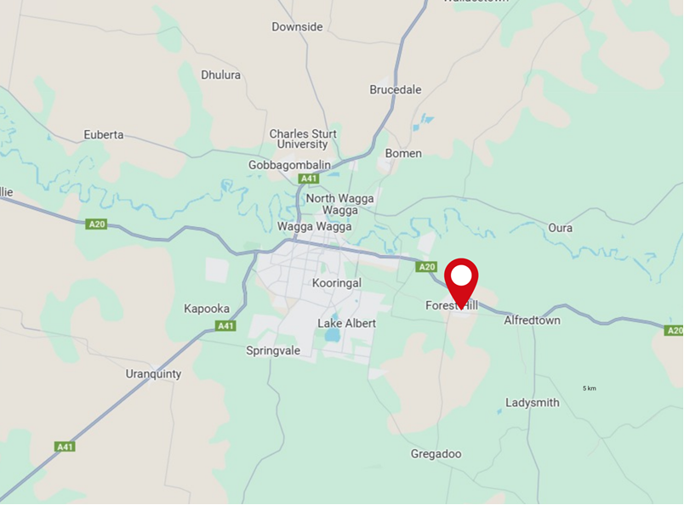

Site Map – Airport Café

Terminal Building – Café Area (Replace with new photos)

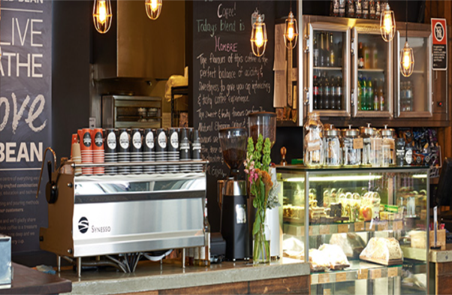

Airport Café Floorplan

Proposed Lease Terms

Subject to resolution of Council the successful applicant **may** receive a lease offer comprising the following key elements:

|  |  |
| --- | --- |
| Premises | Airport Cafe, Wagga Wagga Airport, Don Kendell Dr, Forest Hill NSW 2651. Part Lot 1 DP 1113351. |
| Lease Term | By negotiation, ending 29 June 2026. |
| Option to Renew | Lease renewal is subject to negotiation and contingent upon the renewal and terms of the airport head lease. |
| Lease Commencement | By negotiation. |
| Permitted Use | Retail café for the preparation, sale and serving of hot and cold foodstuffs; hot and cold beverages, alcoholic beverages, coffee beans, coffee products, newspapers, magazines, snacks, confectionary, toiletries and travel essentials. |
| Initial Annual Rent | Subject to negotiation as part of the EOI process. Payable in monthly instalments. |
| Method of payment | Monthly in advance on the first day of each calendar month. |
| Outgoings | All outgoings associated with the leased premises including water and gas usage are payable by the Lessee. |
| Preparation Fees | Lesse to pay lease preparation costs of $295 |
| Trading hours (minimum) | * Monday through to Saturday including Public Holidays - 6am – 7pm * Sunday - 7.30am – 6.30pm   The lessee is not required to trade on Christmas Day or Good Friday; however, the Lessee is not prohibited from trading on these days. |
| Maintenance | The Lessee is responsible for routine repairs and maintenance of all fixtures, fittings and improvements within the leased premises and inclusions.  The Lessor is responsible for all structural repairs and maintenance (unless required due to the Lessee’s use of the premises).   Upon the termination of the lease agreement, the Lessee is required to return the premises, including all inclusions, in the same condition they were at the start of the lease agreement, allowing for fair wear and tear. |
| Insurance | The Lessee shall affect and maintain public liability insurance in the sum of $20 million. Council is to be listed on the policy as an interested party.  The Lessee shall affect and maintain contents insurance for all contents belonging to the Lessee. |
| Liquor Licence | The Lessee is permitted to provide liquor in the seating area subject to the Lessee obtaining the relevant permission from Liquor and Gaming NSW and alcohol is only to be consumed by the patrons of the establishment while situated in the seating area or within the lease area. All alcohol consumption must be within the terms of the licence granted by Liquor and Gaming NSW the to the sub-lessee. |
| Airport Regulations | The Lessee agrees to comply with all regulations, legislative requirements and Lessor’s policies and procedures in relation to the operation of Wagga Wagga Airport. |
| Special Conditions / Additional Provisions | The provisions of the head lease will apply to the lease and will be incorporated as if set out in length.  Wagga Wagga Airport, Don Kendell Dr, Forest Hill is zoned SP2 (Special Purpose Zone 2) under the Wagga Wagga Local Environmental Plan 2010. The Lessee will be required to obtain any necessary statutory approvals for their proposed use at their own cost. Such approvals may include development consents, registration of food premises and trade waste approvals.  Car parking will be allocated for up to 2 café staff at all times.   The Lessee must provide Council with annual reporting statements to include information on income and expenditure and activities relating to the Lease Premises upon request. |

Inspections

Council will organise and coordinate all inspections of the premises during the EOI campaign. To arrange an inspection, please contact:

Matt Dombrovski

Property Coordinator

dombrovski.matthew@wagga.nsw.gov.au

1300 292 442

Steph Wilson

Senior Property Officer

wilson.stephanie@wagga.nsw.gov.au

1300 292 442

Questions and answers noted during inspections that offer additional or alternative information to the details in this document will be shared with all parties who have registered interest via updates on the dedicated EOI Have Your Say web page. However, questions and answers relating to an individual applicant’s specific circumstances or EOI submission will remain confidential and will not be publicly disclosed.

Selection Criteria

All complying EOI submissions received will be assessed against the selection criteria detailed below.

Council reserves the right to not accept any proposal or submissions for the leasing of the café, including those which may comprise the highest annual rental offer. Council also reserves the right to consider offers which do not conform with the selection criteria where Council considers there would be an exceptional public benefit in considering the submission.

Applicants may be required to consent to financial or other checks by Council.

|  |  |
| --- | --- |
| **Required Information** | |
| **Applicant Details** | Applicant Name: |
| Business Name: |
| ABN/ACN: |
| Postal Address: |
| Phone: |
| Email: |
| **Selection Criteria** | |
| 1. Presentation of a business plan for proposed activities for the lease period. | |
| 1. Outline your experience in the hospitality sector and in managing a hospitality business. | |
| 1. Provide details of current accreditations and qualifications that are relevant to the provision of services. | |
| 1. Provide proof of your financial capability, supported by records of past financial performance over the last two years, along with corresponding financial statements. | |
| 1. Proposed annual licence fee (excluding GST). | |
| 1. Confirm your commitment to fulfilling the lease conditions, including adhering to the minimum trading hours and the submission of annual trading figures. | |
| 1. A minimum of two (2) current business references. | |

Submission Process and Timeline

**The closing date for EOI submissions is Friday XX MONTH 2025 at 5.00pm.**

Any submissions received after the deadline will not be considered.

Applicants **must** complete the attached EOI application form, addressing the selection criteria in detail, and including supporting documentation such as business plans or relevant financial information. Any EOI submissions that fail to address the selection criteria or provide the necessary supporting documentation by the specified closing date and time will not be considered.

Submissions **must** be lodged by one of the methods set out below. Submissions by any other means, or submissions received after the closing date and time will not be considered.

Electronic Submissions: Email to [engedal.borge@wagga.nsw.gov.au](mailto:engedal.borge@wagga.nsw.gov.au)

Hard Copy Submissions: Deliver by hand to Customer Service at the Civic Centre, 243 Baylis St, Wagga Wagga NSW 2650, addressed to the Council Tender Box.

EOI submissions become the property of Council and will be held by Council subject to law. The information provided within the EOI submissions will be utilised by Council to assist in the selection of the preferred applicant and the subsequent lease negotiations.

To review the EOI process and timeline, or to register for updates, please visit the dedicated EOI webpage at https://haveyoursay.wagga.nsw.gov.au/???

Contact Information

For further clarification or information concerning the EOI, please contact:

Matt Dombrovski

Property Coordinator

dombrovski.matthew@wagga.nsw.gov.au

1300 292 442

Steph Wilson

Senior Property Officer

wilson.stephanie@wagga.nsw.gov.au

1300 292 442

Canvassing or lobbying of Councillors and/or other Council staff is strictly prohibited. If an applicant is found to have directly canvassed Councillors and/or Council staff other than as set out in this EOI documentation, Council reserves the right to reject their submission.