Document Matrix Guide for Checklists

Document Naming Convention

When saving and uploading your documents to the Portal, please name the documents in accordance with the document matrix within the relevant checklist for the application.

This will help Council staff easily identify the documents that have been submitted and help ensure that your application is processed without delay.

DA document matrix CC/CDC document matrix
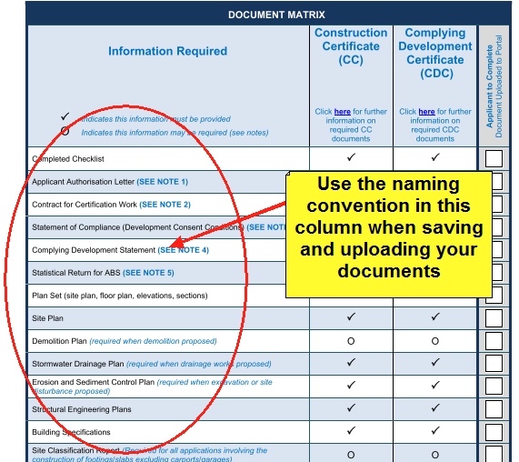
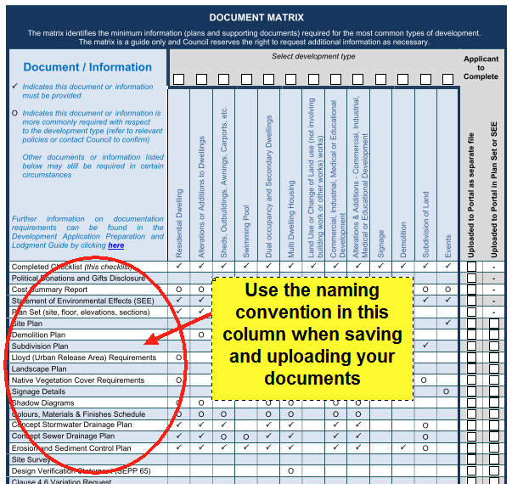

AA document matrix
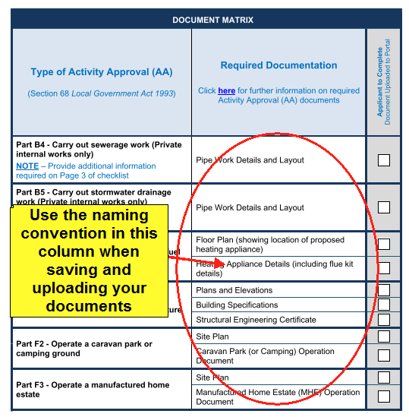

Development Application Checklist

Please ensure that you have completed all pages of the checklist where required and that the entire checklist is uploaded with your application.

The checklist will provide links to other documents that you may be required to complete and submit as part of your application including:

- Cost Summary Report Template
- Reportable Donations and Gifts Disclosure Form

A document matrix is provided within the checklist to ensure that you have uploaded all necessary plans and documentation with your application. Please ensure that the matrix is completed as per the following instructions.

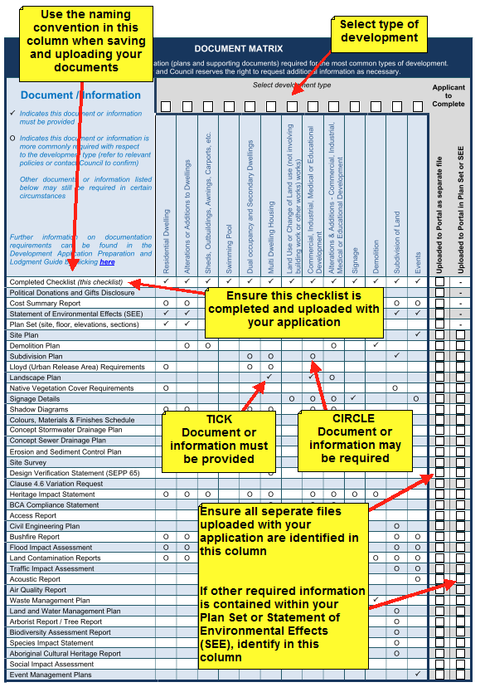

Construction Certificate (CC) and Complying Development Certificate (CDC) Checklist

Please ensure that you have completed all pages of the checklist where required and that the entire checklist is uploaded with your application.

The checklist will provide links to other documents that you may be required to complete and submit as part of your application including:

- Application for Contract for Certification Work
- Statistical Return for ABS

A document matrix is provided within the checklist to ensure that you have uploaded all necessary plans and documentation with your application. Please ensure that the matrix is completed as per the following instructions.

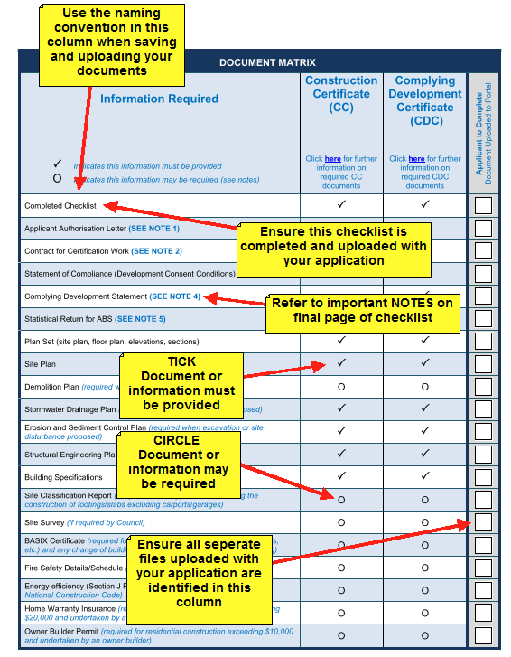

Section 68 Activity Approval (AA) Checklist

Please ensure that you have completed all pages of the checklist where required and that the entire checklist is uploaded with your application.

A document matrix is provided within the checklist to ensure that you have uploaded all necessary plans and documentation with your application. Please ensure that the matrix is completed as per the following instructions.

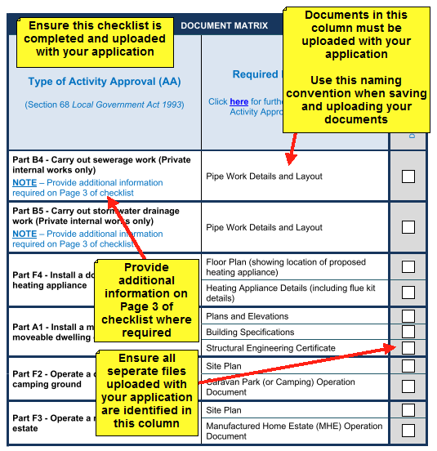

Subdivision Checklists (SWC and SC)

Checklists will be available for both Subdivision Works Certificate (SWC) applications and Subdivision Certificate (SC) applications. These checklists will be available on the Council Planning Portal webpage.

If you have questions or require assistance in completing these checklists, you can contact Council’s Subdivision Section on 1300 292 442.

